**PCPF Lab**

**Lab Assignment number 08**

**Name:** Aamir Ansari **Batch:** A **Roll no.** 01

**Aim:** To execute programs in Prolog

**Problem Statement 1:**

**Write prolog code to check the relationship among individuals (son, daughter, mother,**

**father, grandparent). Consider the facts of your interest and write the rules. Test the**

**knowledge base with some goals.**

**Program:**

Knowledge Base (facts.pl):

% males and females

male(abraham).

male(clancy).

male(herb).

male(homer).

male(bart).

female(mona).

female(lisa).

female(jackie).

female(maggie).

female(marge).

female(patty).

female(selma).

female(ling).

% maritals

married(abraham, mona).

married(mona, abraham).

married(clancy, jackie).

married(jackie, clancy).

married(homer, marge).

married(marge, homer).

% parents

parent(abraham, herb).

parent(mona, herb).

parent(abraham, homer).

parent(mona, homer).

parent(clancy, marge).

parent(jackie, marge).

parent(clancy, patty).

parent(jackie, patty).

parent(clancy, selma).

parent(jackie, selma).

parent(homer, bart).

parent(marge, bart).

parent(homer, lisa).

parent(marge, lisa).

parent(homer, maggie).

parent(marge, maggie).

parent(selma, ling).

/* rules */

son(Child, Parent) :- male(Child), parent(Parent,Child).

daughter(Child, Parent) :- female(Child), parent(Parent,Child).

father(Parent, Child) :- male(Parent), parent(Parent,Child).

mother(Parent, Child) :- female(Parent), parent(Parent, Child).

brother(Sibling, Bro) :- male(Bro), father(Father,Sibling), father(Father, Bro), Bro \= Sibling,

mother(Mother, Sibling), mother(Mother, Bro).

sister(Sibling, Sis) :- female(Sis), father(Father, Sibling), father(Father, Sis), Sis \= Sibling,

mother(Mother, Sibling), mother(Mother, Sis).

grandmother(Grandmother, Grandchild) :- female(Grandmother), parent(Parent, Grandchild),

parent(Grandmother, Parent).

grandfather(Grandfather, Grandchild) :- male(Grandfather), parent(Parent, Grandchild),

parent(Grandfather, Parent).

**Output:**

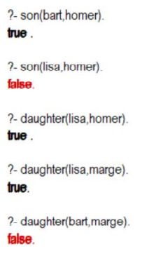.

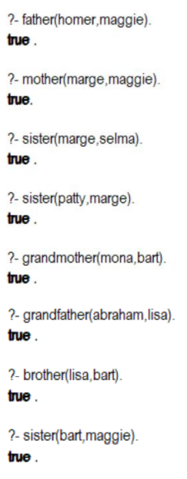

**Problem Statement 2:**

Write Prolog code to find length of the list.

**Program:**

Knowledge Base (facts.pl):

%length of a list

len([],0).

len([_|T],N) :- len(T,X), N is X+1.

**Output:**

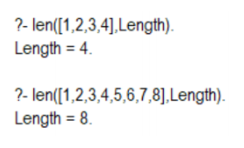Queries: